**PRCO204 Project management review**

Project Management Review 50%

Submit one PDF document from the group detailing an evaluation of your project management approach. You must discuss your application of agile, provide supporting evidence of your approach (See below).

Supporting Evidence To evidence your team’s engagement with the development process, you are required to document key ‘agile artifacts’. Your project documentation will depend primarily on the type of client that you choose to work with. However, there are some tangible artifacts that will form the basis of every project. You will be expected to deliver the following:

• Product roadmap Review the examples on Roadmunk or Aha and produce a suitable roadmap for your client project!

We used a story map as our roadmap, this worked well with the agile philosophy as we were able to set out objectives in terms of functionality for each stage of the project.

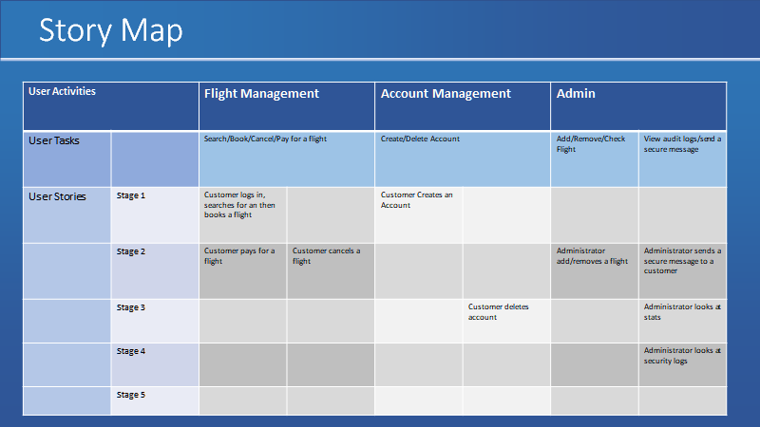

To be completed by joe

• Product backlog Show your project management tool with full product backlog demonstrating who is implementing what.

• Sprints Show evidence of how you plan sprints eg; weekly scrum board or dedicated cards on management.

To be completed by joe

• Release plan What will you deliver to the client and when, what features will be active, summary of release planning here.

• Summary notes of group meetings Show evidence of team communication, documentation of HCI feedback, interim reviews, planning activities.

To be completed by joe

• Minutes of official meetings with clients Show evidence of client communication, what is your agreed method with your client.

The security scenario did not have clients, however feedback from the HCI assessment was useful to make changes to the project. Apart from that we had to evaluate the application as a team and make changes where we felt that was needed.

• Prototype software Functional prototype demonstrating core functionality and features implemented.

The current website represents a functional prototype in terms of a minimal viable product.

• List of software bugs and vulnerabilities Particularly for CIS teams, a list of found software bugs and vulnerabilities, their outcomes, a rank of their risk to the software, and patches/solutions applied to mitigate risk.

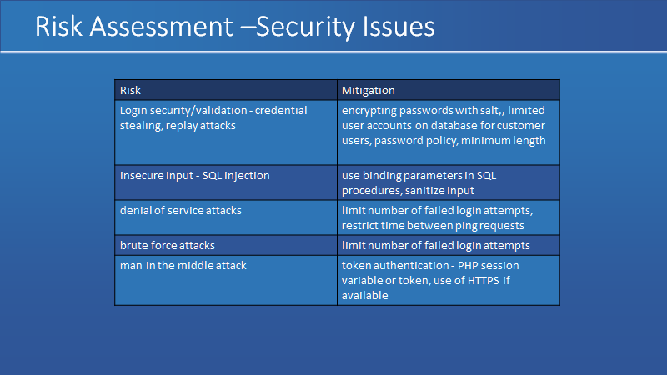

At the start of the project we included a security risk assessment which identified security vulnerabilities and how they could be mitigated. Hashed passwords we used in the database as a security measure, we did not have access to SSL/HTTPS for this project, but if that was available the security could have been increased. Calls to the database were done using binding parameters which protected against SQL injection and an audit log was added which records all reads and writes to the database. A Caesar cipher was implemented to create secure messages. Not all vulnerabilities were mitigated in the risk assessment as we had limited resources.